WhatsApp Messenger

User Guide



Version: 1.0

Copyright

Contact Support

Contents

Introduction 4

Prerequisites 5

Exploring WhatsApp 5

Other functions 7

Getting started 9

Register to WhatsApp 9

Set up your WhatsApp account 9

Using the features 10

Create a Community 10

Concept topic 10

Task topic 10

Start a Chat 10

Learn about Chat 10

How to use Chat 11

Explore more about Chat 12

Add a Status 13

Concept topic 13

Task topic 13

Make Audio/Video Calls 13

Concept topic 13

Task topic 13

Working with Solutions 14

Scenario 1 14

How to Task name 14

Troubleshooting 15

Frequently Asked Questions 16

Best Practices 17

Appendix 18

# Introduction

Welcome!

WhatsApp Messenger (popularly known as WhatsApp) is a simple, reliable, private messaging and calling application owned by US tech conglomerate Meta (known as Facebook earlier). This application is a freeware and the intended users can use without paying a penny. WhatsApp is one of the most popular messaging services across the globe.

You can connect with friends and family in any part of the world using WhatsApp. Various features in this app allow you to interact through text messages, make audio or video calls, share pictures, videos or files to anybody easily.

You can share valuable, sensitive or personal information on WhatsApp without worrying about misuse of them. With end-to-end encryption, all messages are sent and received in a secure environment.

This User Guide contains all essential information for you to use WhatsApp effortlessly. This guide includes descriptions, procedures to use and additional information of every feature and related functions. This guide helps you to explore the application on your own, understand and use all features of WhatsApp.

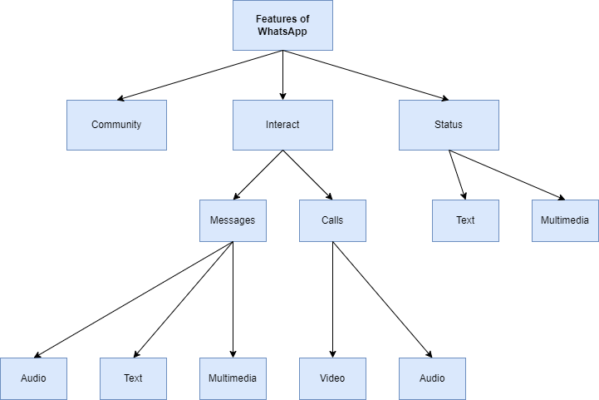

# Prerequisites

You must make sure the WhatsApp application is downloaded and installed on your phone before going through the User Guide.

For more information, refer to the Installation Guide to learn the installation procedure. You can find it here.

# Exploring WhatsApp

This section helps you to get familiar with various features in WhatsApp. Refer Figure 1 for the features and functions that appear when you open WhatsApp application.

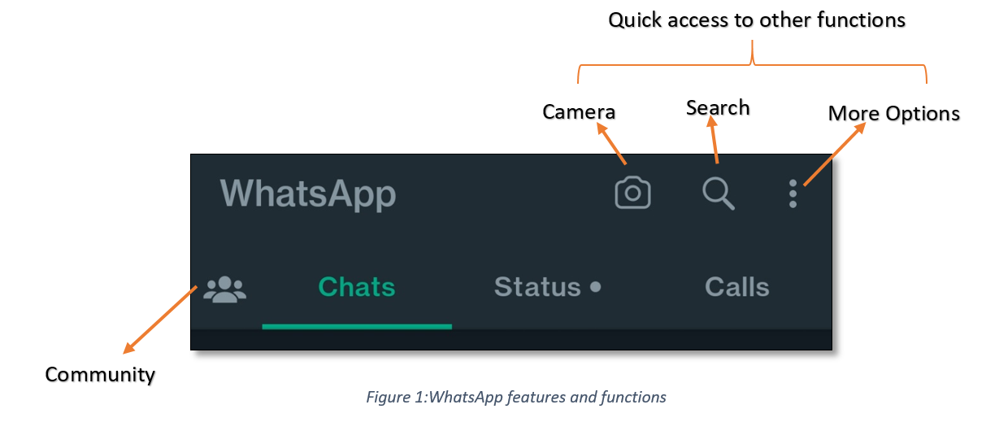

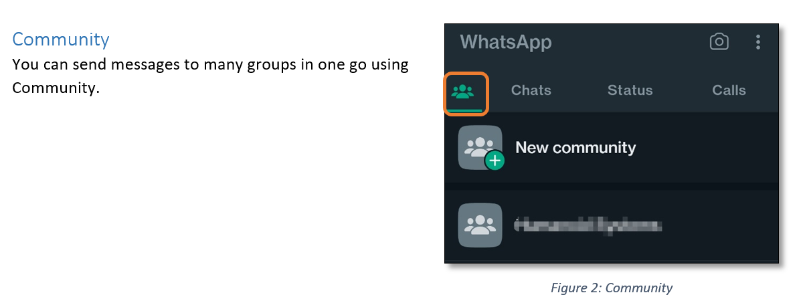

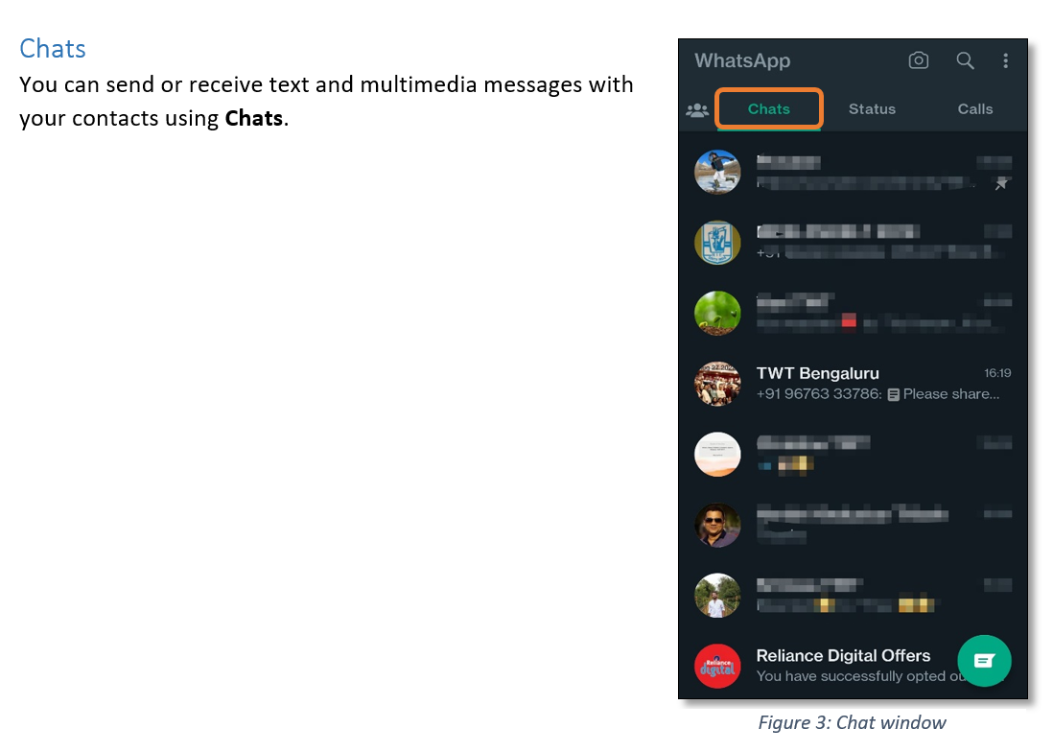

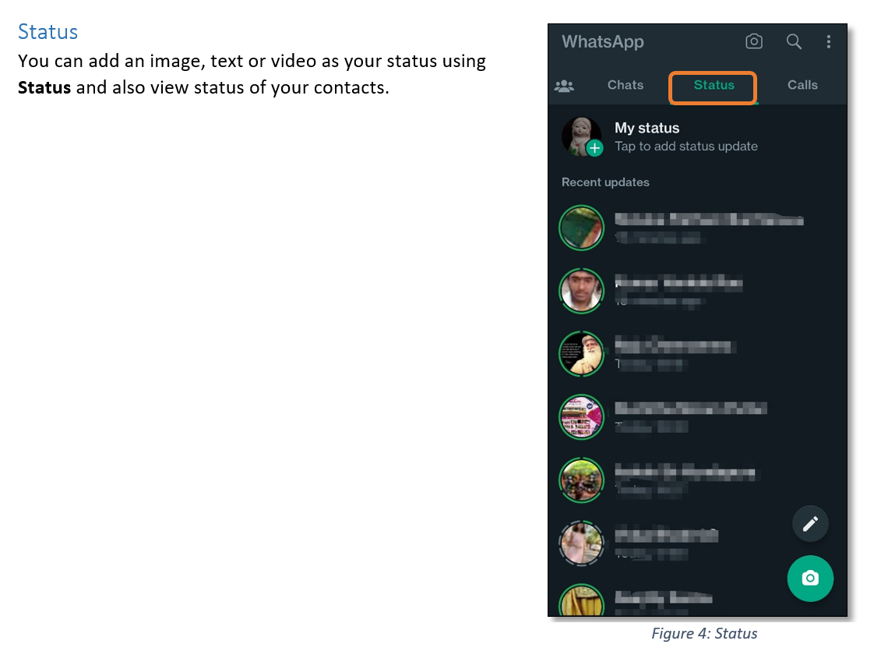

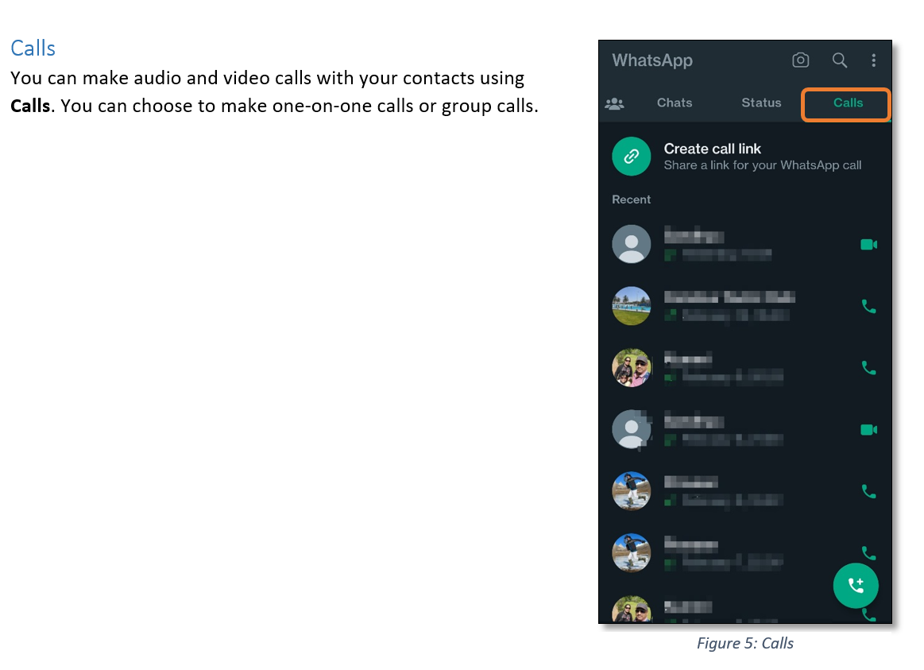

## Other functions

On top right pane, you can see these functions. You can use these functions across different features on WhatsApp.

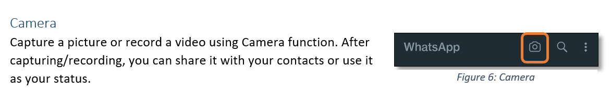

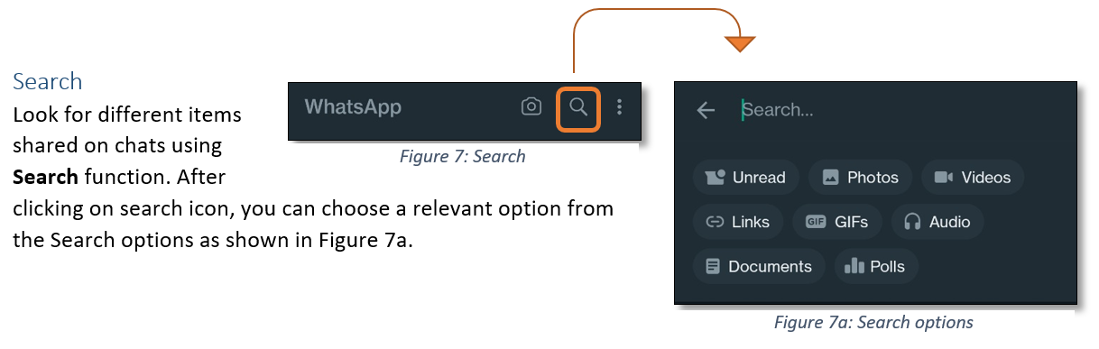

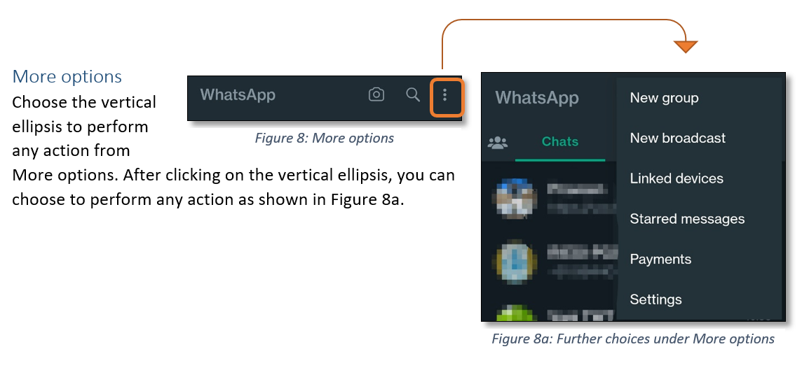

# Getting started

As a user, you can enjoy the benefits of WhatsApp and amazing features of this application. Register to the app, set up your WhatsApp account and start your journey with WhatsApp!

## Register to WhatsApp

This is a simple process and all you need is the app downloaded and installed on your phone. You reach the registration page after you accept the app policy and terms of services.

To register,

1. Select your country from the drop-down list.
2. Add your country code.
3. Enter your phone number.
4. Click on OK to receive verification code via SMS.
5. Enter the verification code.

You are now registered to WhatsApp.

## Set up your WhatsApp account

This is a process to customize your profile in your way.

* Add your name and profile picture to your profile.
* Allow permissions to sync contacts and access location.

Your WhatsApp is ready to use.

# Using the features

Learn to use various features on WhatsApp and explore the vast potential of these features.

## Create a Community

<Introduction>

### Concept topic

<Description>

### Task topic

<Procedure>

## Start a Chat

Interact with your contacts using Chat. Speak your heart out at any moment!

### Learn about Chat

Chat allows you share multiple options during a conversation with an individual or in a group. For example, text and audio messages, pictures and videos, links and documents, and contacts with anybody. Learn about some icons and their functions with respect to Chat before starting a conversation.

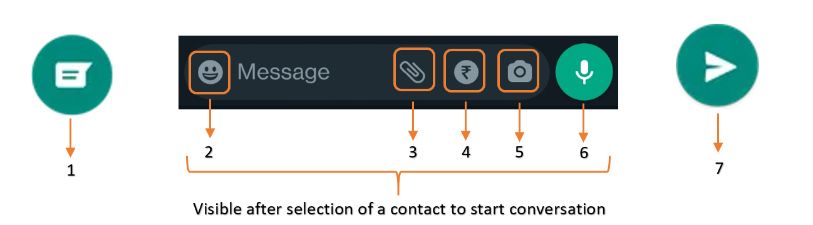

|  |  |  |
| --- | --- | --- |
| **NUMBER** | **NAME OF FUNCTION** | **WHEN TO USE** |
| **1** | New Message | To start new conversation |
| **2** | Emoji | To add emoji, GIF, or stickers to your text messages |
| **3** | Attachment | To attach documents, pictures, videos, audios, and contacts |
| **4** | Send Payment | To make payments |
| **5** | Camera | To capture a picture or record a video and send |
| **6** | Record | To record voice messages and send |
| **7** | Send | To send a text message |

### How to use Chat

You can learn how to start a conversation using Chat. You can chat with an individual or in a group.

To start a chat,

1. Click on new message icon.
2. Select a contact.
3. Type your message in the text box.
4. Click on send icon.

Your message is sent!

You can also explore other messaging options in a chat window in WhatsApp. Long press a message in a chat window to find these options. Refer Figure 9.

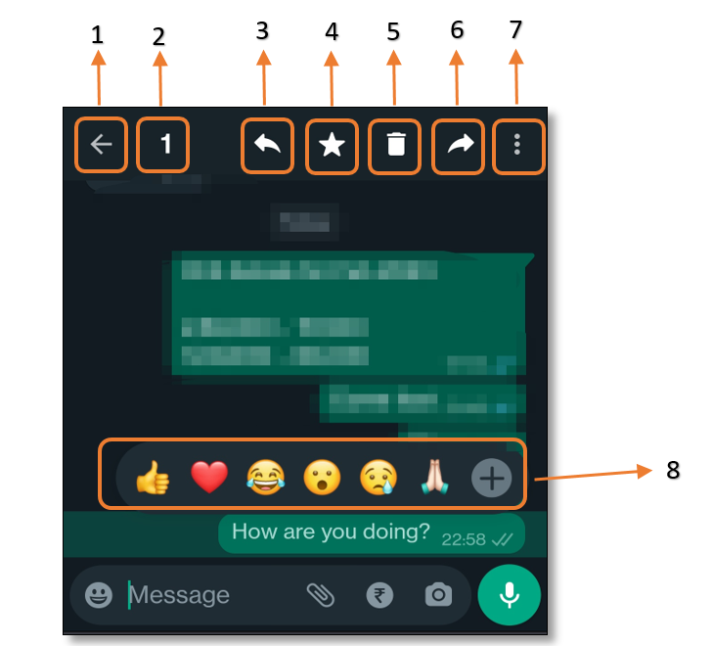

Figure 9: Messaging options

|  |  |  |
| --- | --- | --- |
| **NUMBER** | **NAME OF OPTION** | **DESCRIPTION** |
| 1 | Back | Refers to the option to unselect the message selected |
| 2 | Count | Refers to the number of messages selected in chat window |
| 3 | Back arrow | Refers to the option to quote a particular message and reply to it |
| 4 | Star | Refers to the option to mark a message as important |
| 5 | Delete | Refers to the option to delete selected message |
| 6 | Front arrow | Refers to the option to forward selected message to others |
| 7 | More options | This contains two options,  Info: Use it to find more information on selected message  Copy: Use it to copy selected message |
| 8 | React | Refers to the option to respond to a message with emoji |

To forward a message,

1. Long press a message.
2. Click on front arrow icon.
3. Select a contact to send.
4. Click on send.

You forwarded a message!

### Explore more about Chat

You can use extensive functions of Chat, it is not limited just to send messages.

* Attachment: Use this function to attach any item from the options available. Refer Figure 10 and table to learn more.

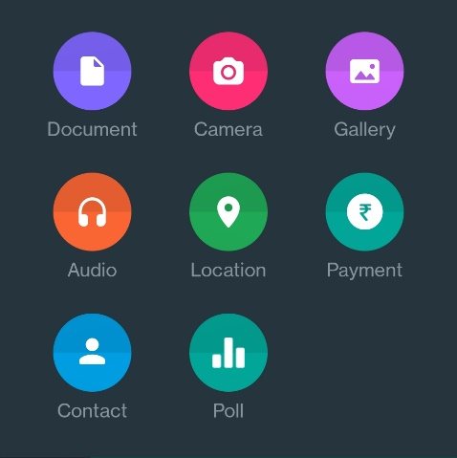

Figure 10: Options in Attachment function

|  |  |
| --- | --- |
| **OPTIONS IN ATTACHMENT** | **DESCRIPTION** |
| Document | To attach a document from your device or drive and send |
| Camera | To capture a picture or record a video and send |
| Gallery | To select a picture or video from your gallery and send |
| Audio | To select an audio clip from your device or drive and send |
| Location | To share your location |
| Payment | To make payments |
| Contact | To select a contact from your list and send |
| Poll | To start a poll |

* Payment: Use this function to make payments from UPI to your contacts. Refer Figure 10.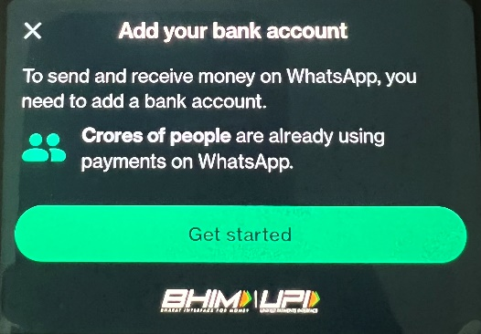

Figure 10: Payment

## Add a Status

<Introduction>

### Concept topic

<Description>

### Task topic

<Procedure>

## Make Audio/Video Calls

<Introduction>

### Concept topic

<Description>

### Task topic

<Procedure>

# Working with Solutions

<Description>

## Scenario 1

<Introduction>

### How to Task name

<To ___,>

# Troubleshooting

# Frequently Asked Questions

# Best Practices

# Appendix